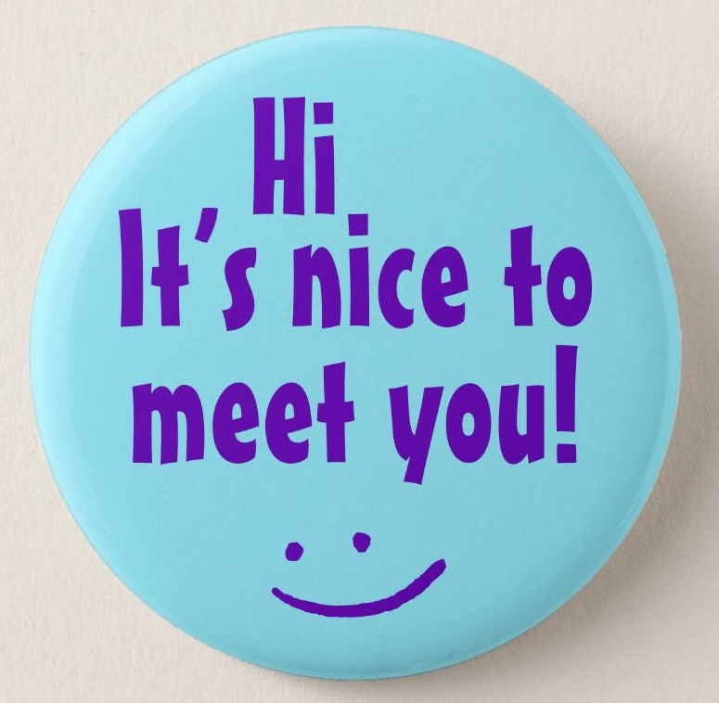
Welcome to Nishikigaoka SHS!

Self-Introduction

Name (in romaji please)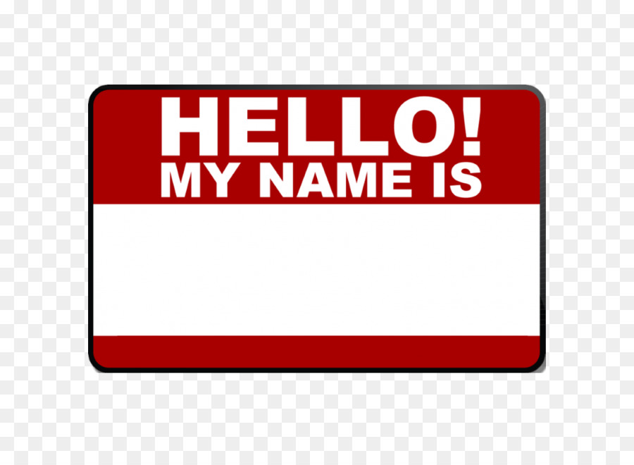: ________________________________________________

Nishiki home room (11H/12H/…): _____________________________________________

Junior High School : ____________________________________________________

Hobbies :

_____________________________________________________________

_____________________________________________________________

Favorite Food : ________________________________________________________
What is one thing you want to learn in English?

_________________________________________________________________________

_________________________________________________________________________

_________________________________________________________________________

Your ALTs:
Lewis Wilson Hannah Varacalli
(ルイス ウィルソン) (ハナ バラカリ)


(Optional) What is your best memory?:

- My favorite class activity is group work / pair work / working by myself. (circle ONE)

- :) My favorite part of English class last year was: ________________________

- :( My least favorite part of English class last year was: ____________________

- ALTs Lewis and Hannah love music! Please recommend one song to them:

- Is there anything you want Hannah and Lewis to know?

