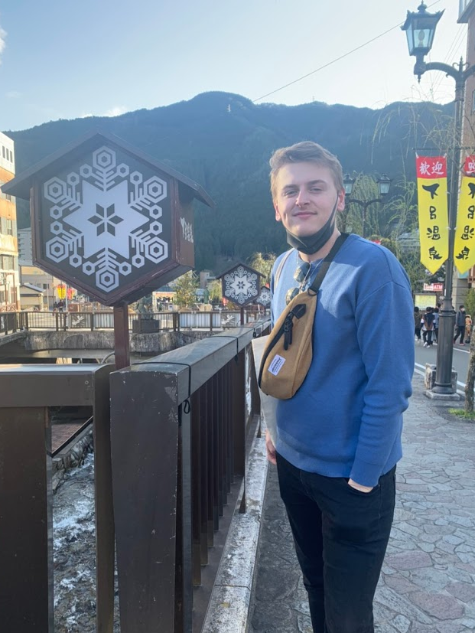
Welcome to Nishikigaoka SHS!

ALT Self-Introduction

Name 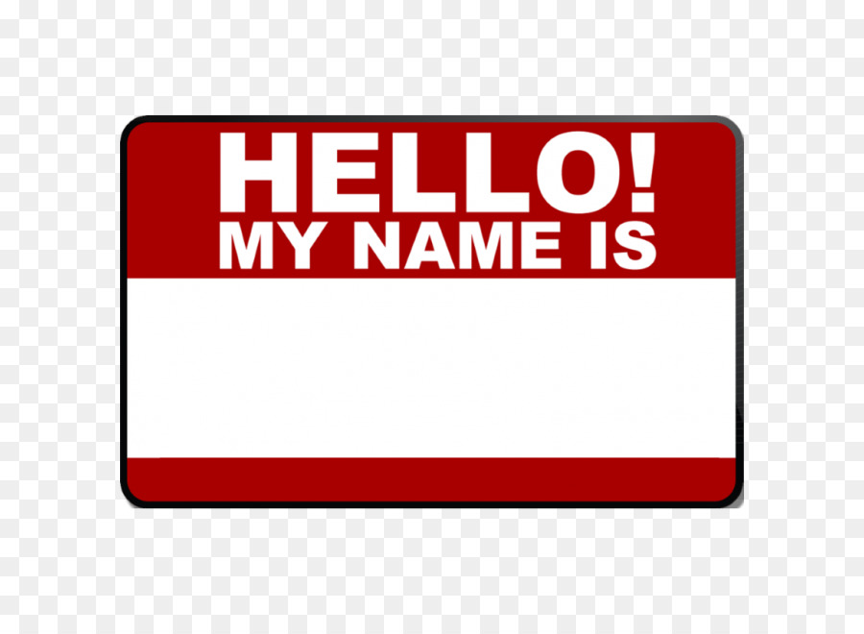: My name is Lewis (ルイス)

Country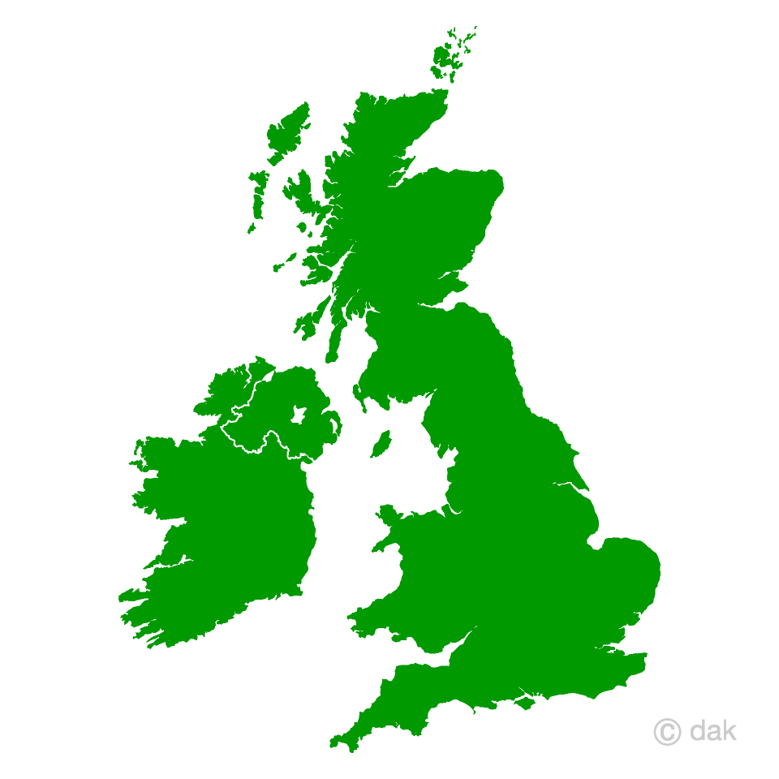: I am from England! (イギリス)

Hobbies :
- I like listening to music (my favorite is rock music, but I also like pop music artists like Ed Sheeran and even Kyary Pamyu Pamyu - I went to her live concert in London!),
- I also like Computer Programming;
- Sometimes I study Japanese!
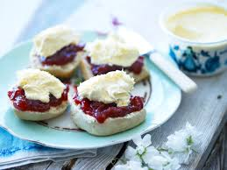
Favorite Food 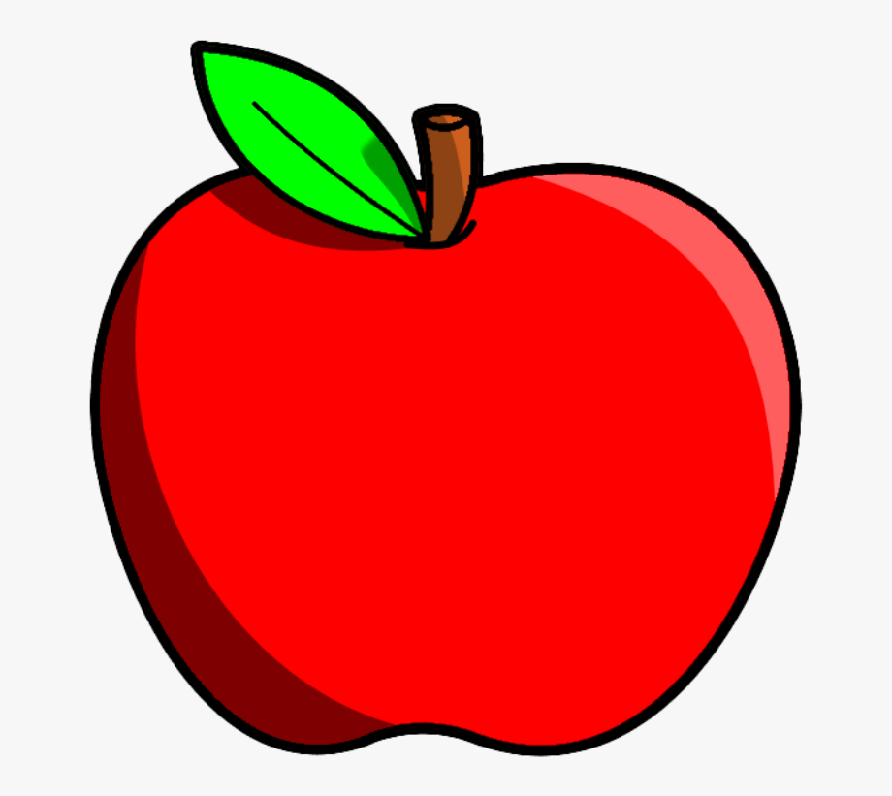:
- (English Food): Cream Tea - Jam and Cream with Scones.
- (Japanese Food): Yakiniku or Shabu Shabu!



What is your best memory?:

My best memory is going to an island in the Philippines last year (2019). The place I went to was called “El Nido”. It was very beautiful and very hot! It was an unforgettable experience.

My message:
I’m happy to welcome you to Nishiki Senior High School. I want to get to know you very well! I hope you enjoy learning English with me, Hannah and the other English teachers. Let’s have fun together!

